How to prepare and do PE using PEA (Practical Exam AutoGrading tool)
on FUG’ local network?

Some works a student should do for preparation of PE:
The PE usually contains 3 questions, the solution for each question is included in separate folder. To minimize the preparative works to PE, you better create a folder used for PE. For example, if your name is HungNV, you create a folder name HungNV_PE. Inside this folder, you create sub-folders Q1, Q2 and Q3. In each of these folders you create 2 sub-folders named: RUN and SRC. When you finish Q1, copy the compiled file (*.exe) to the folder RUN and the source file (*.cpp) to the folder SRC.
When submitting, you select the folder Q1 for the question 1, the folder Q2 for the question 2,…

Steps to be done when doing PE:
Down load the file: \\fstu\Khao_Thi\03_Exam_Online\PEAClient_Version4.zip from the FU local network,
Extract the downloaded file and run the PEALogin.exe file. The following window appears on the screen:
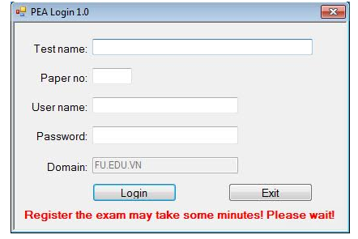
Enter Test name given by a proctor. Enter Paper no on the second page of the exam paper, Enter password, Which is your password for accessing the local network.

3. On login success the widow below appears:
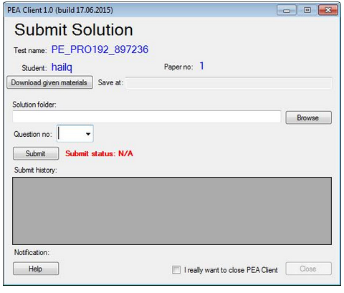
Click on the tab “Download given materials”, then select the folder where you want to save the downloaded files and click “Ok” to start down loading. Open the selected folder, you see sub-folders Q1, Q2,... Q1 contains Q1.cpp, Q2 contains Q2.cpp,... You now complete these files according to questions on the exam paper. When one question is finished, you copy *.exe file into the folder Q1\RUN, the *.cpp file into the folder Q1\SRC in the folder HungNV_PE. To summit Q1, you should select question 1, then click “Brown”, select the folder Q1 and click “Submit”.

